IN PASSENGER PANEL

OPTIONS TO BE DONE

1.VIEW INFORMATION:SO HERE YOU NEED TO INSERT ALL THE DATA OF THE TRAINS OF MINIMUM OF 12-15 TRAINS IN THE FORMAT OF IMAGE INSERTED BELOW 1.1

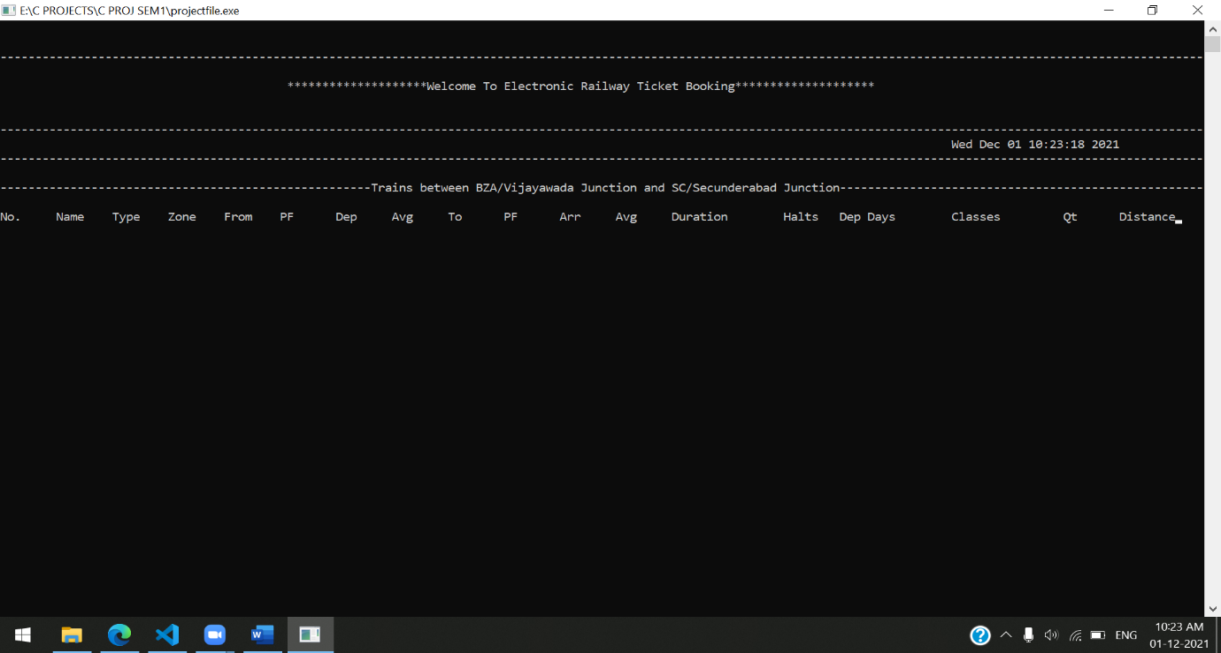

IMAGE 1.1

SO YOU NEED TO INCLUDE ALL THE TRAIN DETAILS SO I WILL BE PROVIDING ALL THE DATA FROM WHERE YOU NEED TO GET THAT

LINK: [310 COVID-19 Special Arrivals at Vijayawada SCR/South Central Zone - Railway Enquiry (indiarailinfo.com)](https://indiarailinfo.com/arrivals/vijayawada-junction-bza/29)

AND IN THE END GIVE AN OPTION SO THAT AGAIN WE SHOULD RETURN TO THE PREVIOUS MENU LIKE THAT I HAVE MENTIONED IN PASSENGER MENU 6TH OPTION

2.BOOK TICKET

SO HERE 1ST WE NEED TO ASK FOR TRAIN NUMBER AND DATE AND THEN NO OF TICKETS THEN WE NEED TO ASK FROM STATION AND TO STATION AND THEN WE NEED TO ASK THE DETAILS OF THE PASSENGERS LIKE NAME AGE,GENDER,ETC….

HERE we also need to include an option do they need wifi if yes add charge for that also and wifi password would be their ticket number that to be mentioned.

3.CANCEL TICKET

SO HERE THE USER NEED TO ENTER THE TICKET NUMBER AND PHONE NUMBER AND THEN HE CAN CANCEL THE TICKET

4.PNR STATUS

HERE WE NEED TO ENTER THE PNR STATUS SO THAT USER CAN SEE THE STATUS OF THE TICKET EITHER THE TICKET IS CONFORMED OR NOT

5.FOOD CATERING

HERE WE NEED TO KEEP A MENU OF FOOD AND FARE CHARGES AND WE NEED TO 1ST TAKE THEIR TICKET NUMBER SO THAT WE CAN MENTION THAT AS SOON AS THEY ARE DEPARTED IN TO THE TRAIN THEIR FOOD WILL BE DELIVERED TO THEM

**NOTE:**IN EVERY OPTION YOU SHOULD KEEP AN OPTION TO RETURN TO THE PREVIOUS MENU